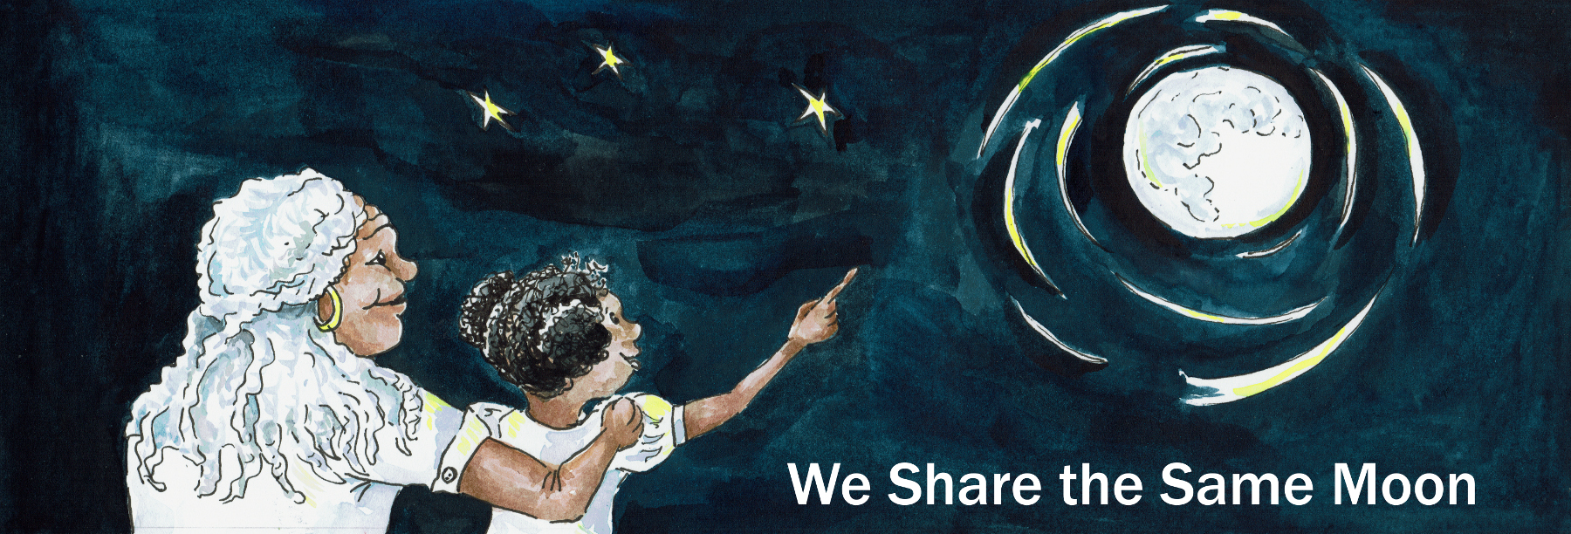
We’re going to travel, travel, travel to the Moon.
We’re going to travel, travel, travel to the Moon.
We’re going to travel, travel, travel to the Moon.

Long ago in the country called Bolivia, there was a mountain, a big mountain,
that went up and up and up and up and up and up into the sky.

And, at the bottom of the mountain there is a tiny hole.
And in this hole, there lives a very special animal called Skunk.
`Now Skunk, he has black and white stripes and a long bushy tail,
And when he is scared, Euw, he lets out a very bad smell!

Skunk, he sleeps all day, but when the Moon rises at night, whoosh,
The light shines onto his hole and wakes him up!

Skunks climbs out of his hole, climb, climb, climb, climb, climb!
And looks up at the Moon “Hello Moon!”
Skunk loves the Moon very much, because, when the Moon shines, ting!
He can see his food!

When the Moon shines, Skunk, he looks and looks and looks and looks and looks and looks and sees “Ahah! Berries! Yum, yum!”
So, he walks and walks and walks and walks,
And he picks and picks and picks and picks,
And he eats and eats and eats and eats.
Chomp, chomp, chomp, chomp! Yum Yum Yum Yum!

Then the Moon begins to set, whoosh, and the Sun begins to rise, whoosh
And Skunk, he knows, It is time to go home and sleep.
So he walks and walks and walks and walks back home. “Thank you Moon!
He climbs back into his hole, climb, climb, climb, climb climb!
“Good-night Moon!”And curls up and goes to sleep.

This he does every night, night after night after night after night!
Skunk loves to look up at the Moon every night,
And he sees something very curious, the Moon changes shape!

Sometimes it’s big and round! And then, it turns into the shape of a banana!
And then, it disappears from the Sky! Where does the Moon go?
And then, it re-appears and gets bigger and bigger and bigger again!
Skunk, loves to look up at the Moon, because every night it is so different!

One night Skunk, he has an idea - ting! “I know! I know! I know!”
I will go and visit the Moon and thank her for the light!
But, how will I travel to the Moon? He thinks for a while. “Hmmm”
He has an idea - ting! “I know ! I know! I know! I will walk to the Moon!”

And so he starts to walk:

I am going to walk, walk, walk to the Moon. I am going to walk, walk, walk to the Moon
I am going to walk, walk, walk to the Moon I am going to walk, walk, walk to the Moon

And he walks and walks and walks and walks - all night long!
But does he reach the Moon? No! The Moon is too far away!
Skunk is very disappointed. Oh ….

The Moon begins to fall and the Sun begins to rise, whoosh
And Skunk, he knows it’s time to turn around and walk back home.

I am going to walk, walk, walk back home.I am going to walk, walk, walk back home.
I am going to walk, walk, walk back home. I am going to walk, walk, walk back home

He climbs into his hole, climb, climb, climb, climb, climb!
“Good-night Moon!”And curls up and goes to sleep

But …
The next night, he climbs out of his hole, climb, climb, climb, climb, climb!
Looks up at the Moon "Hello Moon” And he has an idea - ting!
“I know, I know, I know! I will ask a friend to help!”

So he looks and looks and looks and looks and sees Horse!
“Horse - will you help me to go to the Moon?”And Horse says “Yes!”

So, Skunk climbs onto Horse’s back and they start to gallop

We are going to gallop, gallop, gallop to the Moon.
We are going to gallop, gallop, gallop to the Moon.
We are going to gallop, gallop, gallop to the Moon.
We are going to gallop, gallop, gallop to the Moon.

And they gallop and they gallop and they gallop and they gallop all night long!

But do they reach the Moon? No! The Moon is too far away!
Skunk is very disappointed. Oh….

The Moon begins to set and the Sun begins to rise, whoosh
And so they know it is time to turn around and go back home.

So:

We are going to gallop, gallop, gallop back home.
We are going to gallop, gallop, gallop back home.
We are going to gallop, gallop, gallop back home.
We are going to gallop, gallop, gallop back home.

"Thank you Horse!”

Skunk climbs down into his hole, climb, climb, climb, climb, climb!
“Good-night, Moon” And curls up and goes to sleep.

But …
The next night, he climbs out of his hole, climb, climb, climb, climb, climb!
“Hello Moon!”And he had an another idea - ting!
“I know! I know! I know! I shall ask another friend to help!”
So he looked and looked and looked and looked and saw Bear!
Bear - will you help me go up the Mountain to the Moon?
And Bear says “Yes!”

So Bear picks him up and together they climb the Mountain.

We are going to climb, climb, climb to the Moon.
We are going to climb, climb, climb to the Moon.
We are going to climb, climb, climb to the Moon.
We are going to climb, climb, climb to the Moon.

And they climb and climb and climb and climb, until they reach the top of the Mountain!
And there is the Moon. Just within reach! Skunk , he stretches and stretches …
But can he touch the Moon? No! It is too far away!
And Skunk is very disappointed. Oh ….

The Moon begins to set and the Sun begins to rise, whoosh!
And so they know it is time to turn around and go back home.

So, we are going to climb, climb, climb back home.
We are going to climb, climb, climb back home.
We are going to climb, climb, climb back home.
We are going to climb, climb, climb back home.

“Thank you Bear!”

And Skunk climbs into his hole climb, climb, climb, climb, climb!
“Good-night Moon!” And he curls up and goes to sleep.

But, the next night,
Skunk climbs out of his hole, climb, climb, climb, climb, climb!
“Hello Moon”And he has another idea - ting!
“I know! I know! I know! I will ask another friend to help!”

So he looks and looks and looks and looks and sees Owl!
Owl! Will you fly me to the Moon? And Owl says “Hmmm. Yes”
So, Skunk climbs onto Owl’s back and together they fly to the Moon.

We are going to fly, fly, fly to the Moon. We are going to fly, fly, fly to the Moon.
We are going to fly, fly, fly to the Moon.

The Owl and the Skunk they fly and fly and fly, closer and closer and closer
Skunk stretches and stretches … Ah! And he touches the Moon!
“Thank you Moon. Thank you for the light!”
And Skunk strokes the Moon gently with his paw! “I love you Moon”

But…
It is very cold up there by the Moon
And Owl says “Quick - it is too cold. We must go home!”
So they turn around and fly back home.

We are going to fly, fly, fly back home. We are going to fly, fly, fly back home.
We are going to fly, fly, fly back home.

“Thank you Owl”

And Skunk climbs back into his hole, climb, climb, climb, climb, climb!
“Good-night Moon!”And curls up and goes to sleep,
Happy that he has now touched the Moon.

And so he lives - happily ever after!

But, but, but … In the country of Bolivia, where this story is from,
They say, that the dark patches you can see on the Moon, are where the Skunk’s paws stroked the Moon on that night so very long ago.

But, but, but … Scientists say, that it was rocks hitting the Moon,
that made the dark patches you can see today

Which do you think is true?
Science or Story?

